**ARIGNAR ANNA GOVERNMENT ARTS COLLEGE-MUSIRI 621 211**

**Affiliated to Bharathidasan University ,Tiruchirappalli**

**TOPIC:**

**VOYAGE VISTA:ILLUMINATING INSIGHTS FROM UBER EXPEDITIONARY ANALYSIS**

**SUBMITED BY:**

**TEAM ID:**

1. **S.VENNILA (31D9B64897E6C7CBC554A70B519E15F4)**
2. **L.THRISHA (840F7C7543BF214940F49669F4C3D9C8)**
3. **E.THAYANITHI (E9FF11EA0C29C2A829D4BFE42D720F92)**

**INTRODUCTION:**

Uber is a multinational transportation network company that operates a ride-hailing platform. It was founded in 2009 by Garrett Camp and Travis Kalanick and is based in San Francisco, California. Uber provides a convenient way for individuals to request rides from drivers who use their own personal vehicles. Uber Driver Analysis refers to the Analyzing the number of trips taken by Uber drivers can provide insights into their overall activity and the demand for rides in specific areas. Daily, Weekly, or Monthly Analysis: Uber's data can be analyzed on a daily, weekly, monthly basis to understand the trends and patterns of trip volumes. This analysis can help identify peak hours or days of high demand and optimize driver availability during those times. Trips can be analyzed based on geographic regions or specific cities to identify areas with higher demand. This analysis can help Uber drivers decide where to focus their driving efforts for maximum efficiency and profitability. The Major of our project is to use data Analyzing techniques to find unknown patterns in the Uber Drives dataset. The research is carried out on Uber drives data collected from the year 2016.

**MILEATONE 1: DEFINE PROBLEM/PROBLEM UNDERSTANDING**

* ACTIVITY 1:SPECIFY THE BUSINESS PROBLEM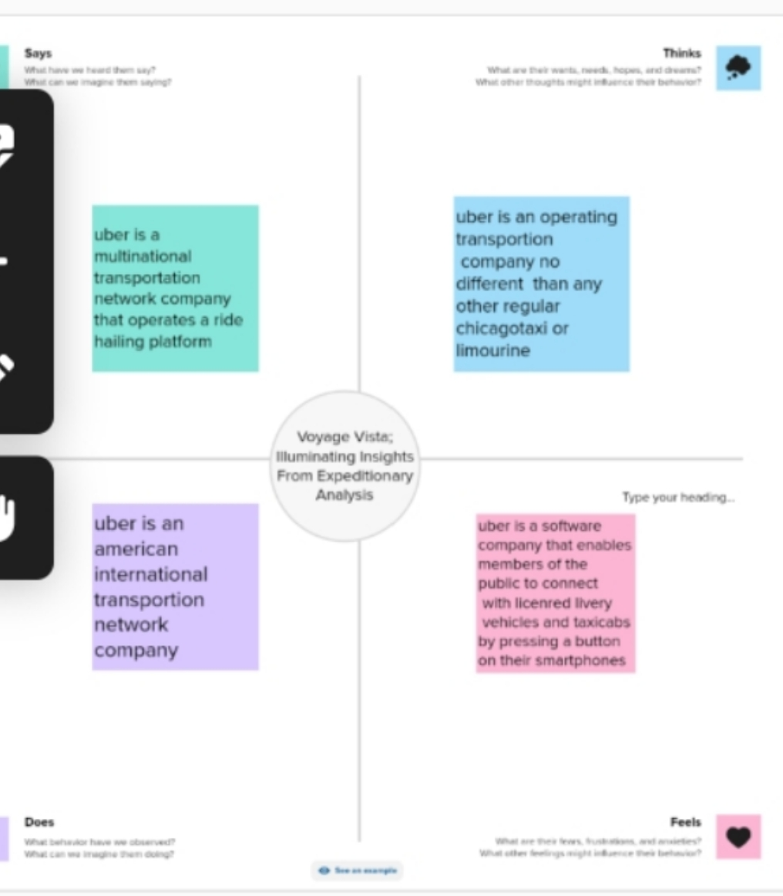

**ACTIVITY 2: REQUIREMENTS**

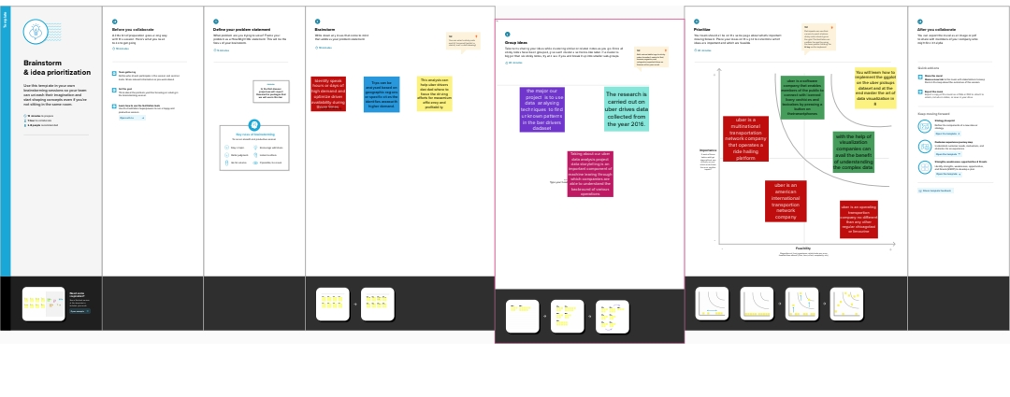**MILESTONE 2:DATA COLLECTION**

**Data collection is the process of gathering and measuring information on variables of interest, in an established systematic fashion that enables one to answer stated research questions, test hypotheses, and evaluate outcomes and g**

**agenerate insights from the data.**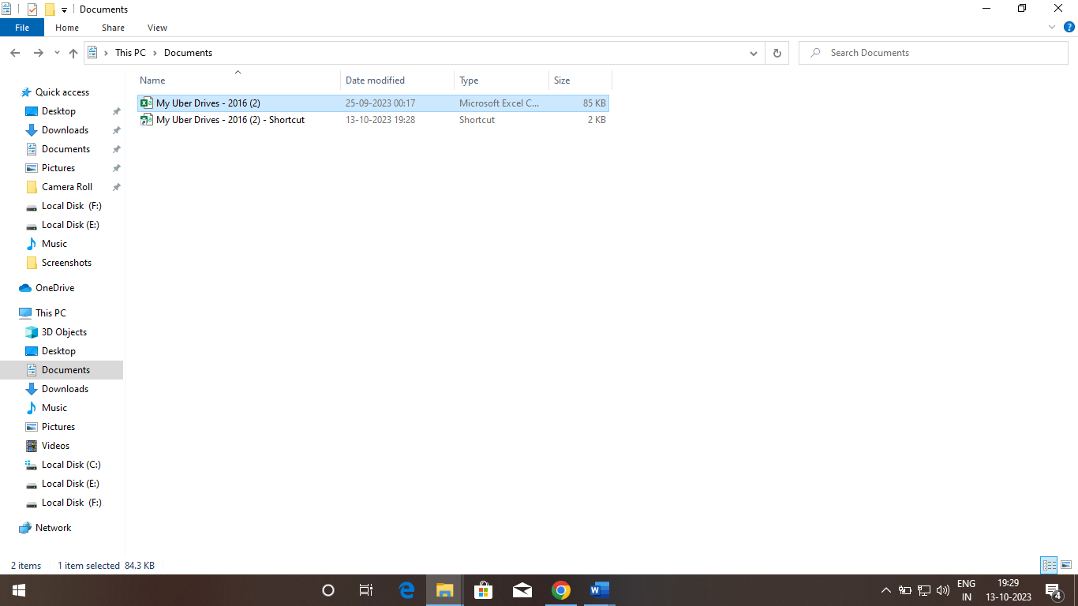

**ACTIVITY 1:THE DATA COLLECTION WITH TABLEAU**

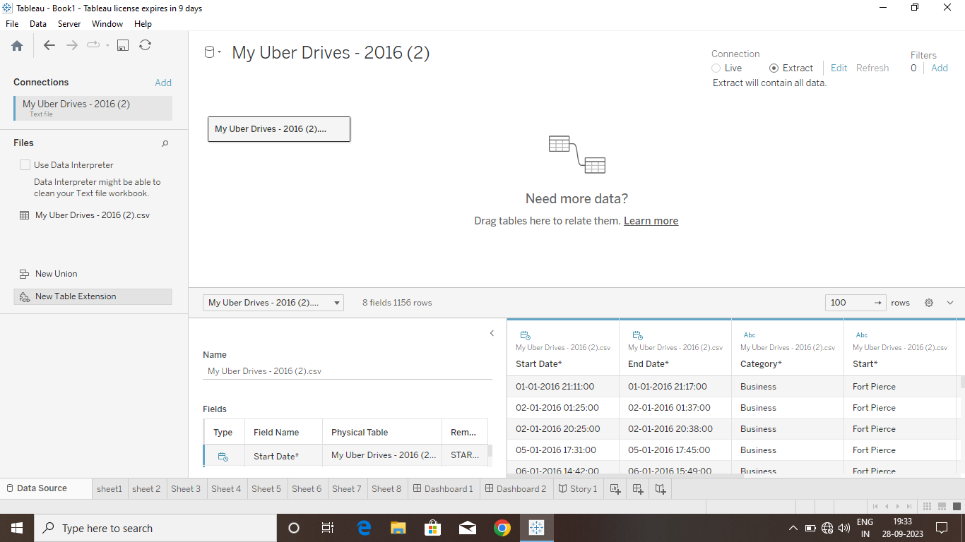

MILESTONE 3: PREPARATION

ACTIVITY 1: the data for visualization involves cleaning the data to remove irrelevant or missing data, transforming the data into a format that can be easily visualized, exploring the data to identify patterns and trends, filtering the data to focus on specific subsets of data, preparing the data for visualization software, and ensuring the data is accurate and complete. This process helps to make the data easily understandable and ready for creating visualizations to gain insights into our analysis.

MILESTONE 3: DATA VISUALIZATIONData visualization is the process of creating graphical representations of data in order to help people understand and explore information. The goal of data visualization is to make complex data sets more accessible, intuitive, and easier to interpret. By using visual elements such as charts, graphs, and maps, data visualizations can help people quickly identify patterns, trends, and outliers in the data.

ACTIVITY 1:NO OF UNIQUE VISUALIZATIONS

The number of unique visualizations that can be created with a given dataset. Some common types of visualizations that can be used to analyze the performance and efficiency of a project include bar charts, line charts, heat maps, scatter plots, pie charts, Maps etc. These visualizations can be used to compare performance, track changes over time, show distribution, and relationships between variables

ACTIVITY 1:MILES COVERED PER CATEGORY AND PURPOSE ANAlYSIS

https:/drive.google .com/file/d/1pnqwqaTIOvhGRca4QCBGFekbgOW7ji/view?usp=sharing

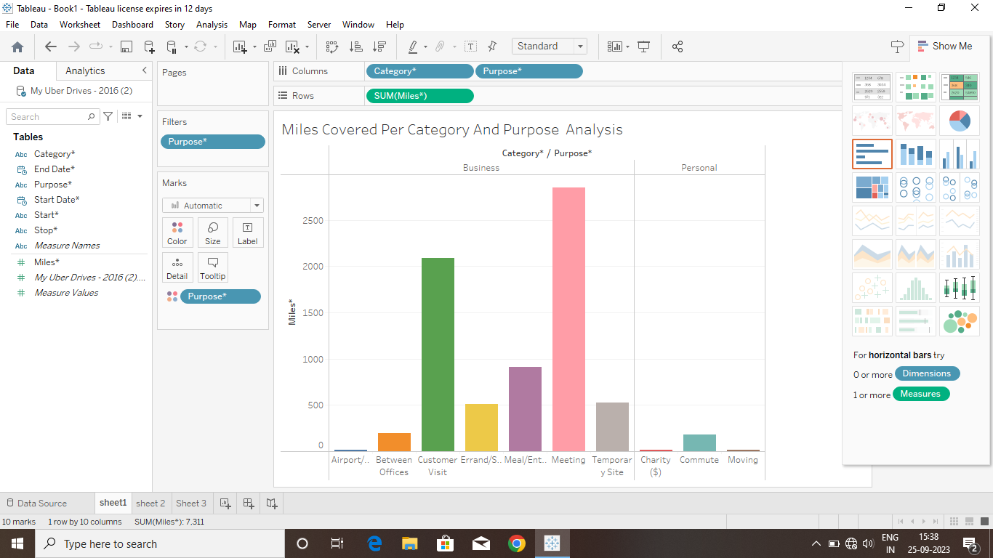

ACTIVITY 1.2 MILES COVRED IN CATEGORY

<https://drive> .google .com/file/d/1 WQGqcVWxi2Ipx4HFDIATCLQIDRJ1Fc/view/usp=sharing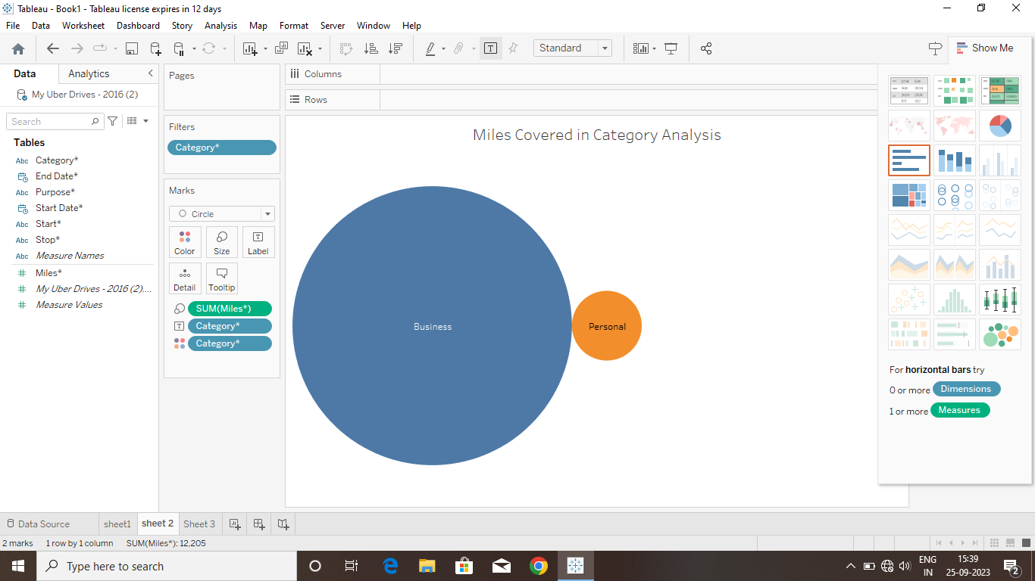

ACTIVITY 1.3 MONTH WISE UBER MILES ANALYSIS

[**https://drive.google.com/file/d/1YKwCna4MnUjOKJDbGWCIIHQEm0WFDqX5/View/usp=sharing**](https://drive.google.com/file/d/1YKwCna4MnUjOKJDbGWCIIHQEm0WFDqX5/View/usp=sharing)

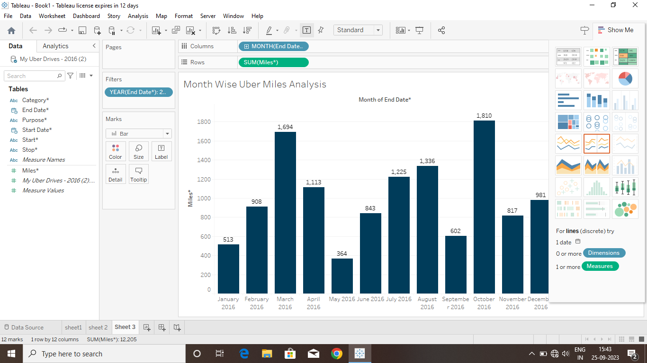

ACTIVITY 1.4 WEEK WISE UBER MILES ANALYSIS

<https://drive.google.com/file/d/1zAJDIWaHTb0neFZFCI9kr> dn9EK526V/view ? usp=sharing

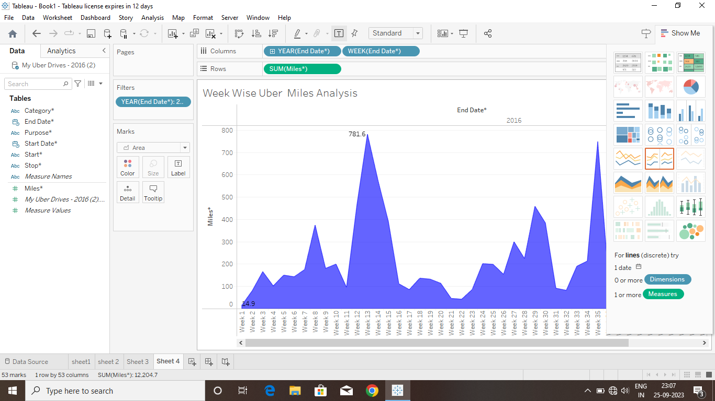

ACTIVITY1.5:QUARTER WISE UBER MILES ANALSIS

<https://drive.google> .com/file/d/1TW1qLUoE DtKQXA2Wd7vmBuQeO2jud81/view?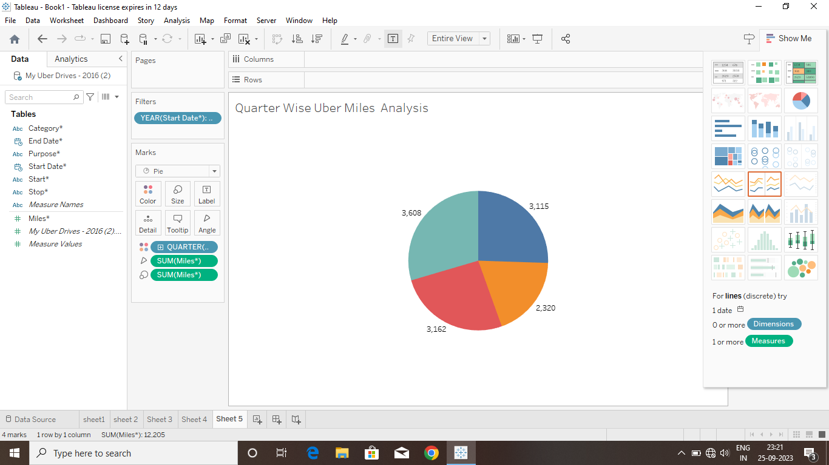

usp=sharing

ACTIVITY 1.6 MONTH WISE UBER TRIPS ANALSIS

<https://drive.google.com/file/d/1ejCMFIntO-Owafb> tv1prWILSATqKtg0/view/USP=sharing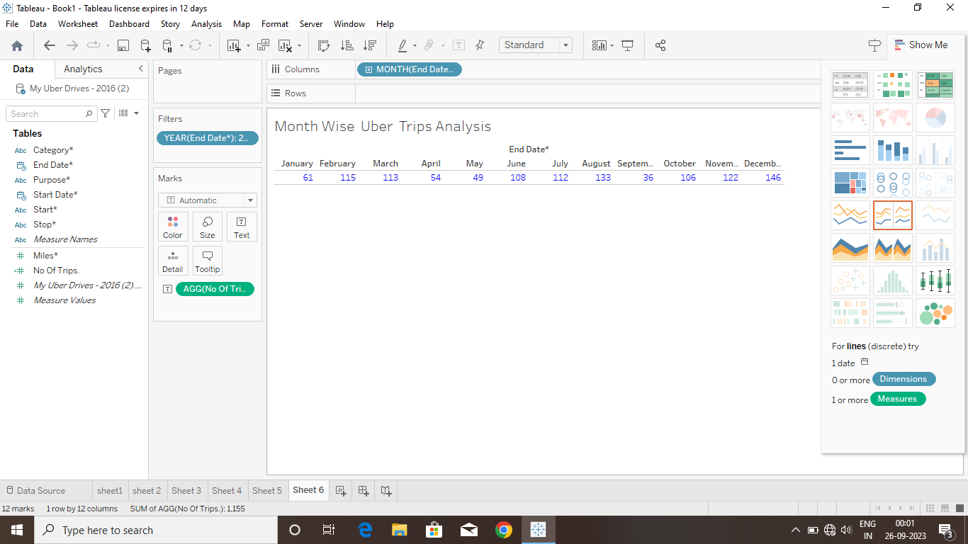

ACTIVITY 1.7 QUARTER WISE UBER TRIPS ANALYSIS

https ://drive .google .com/file/d/1qsTuill8PWFHTxo-OSEZUsxhovrwWYio/view ? USP =sharing

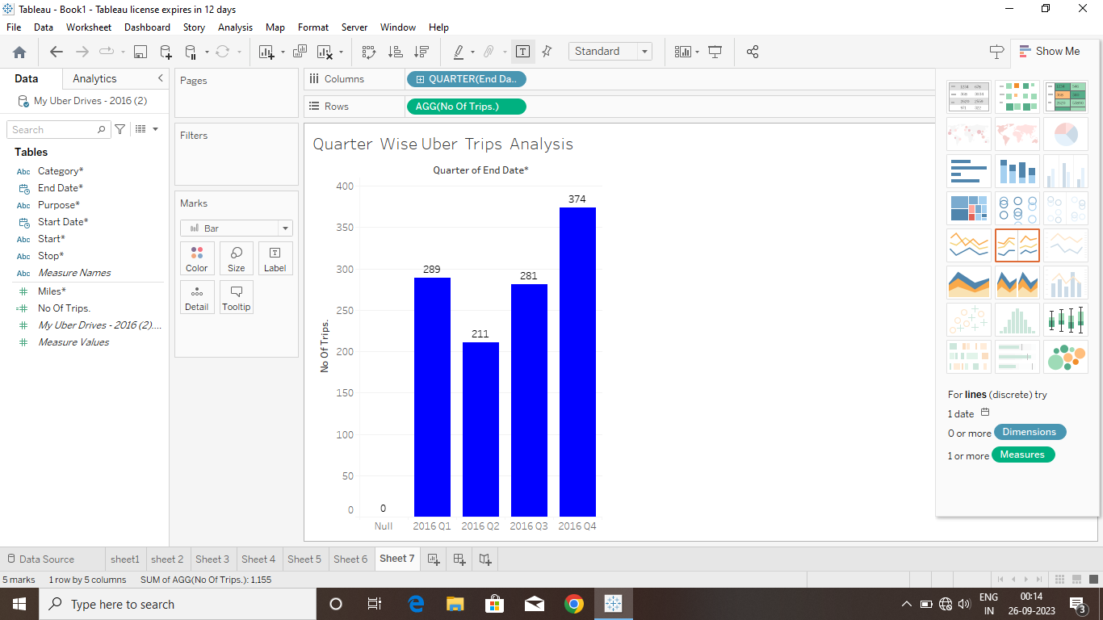

ACTIVITY 1.8:HOUR WISE UBER TRIPS ANALYSIS

https://drive.google .com/file/d/1a2UR0Qrpi0spXvj-FDEMIxSk1XbK5K1E/view? USP=sharing

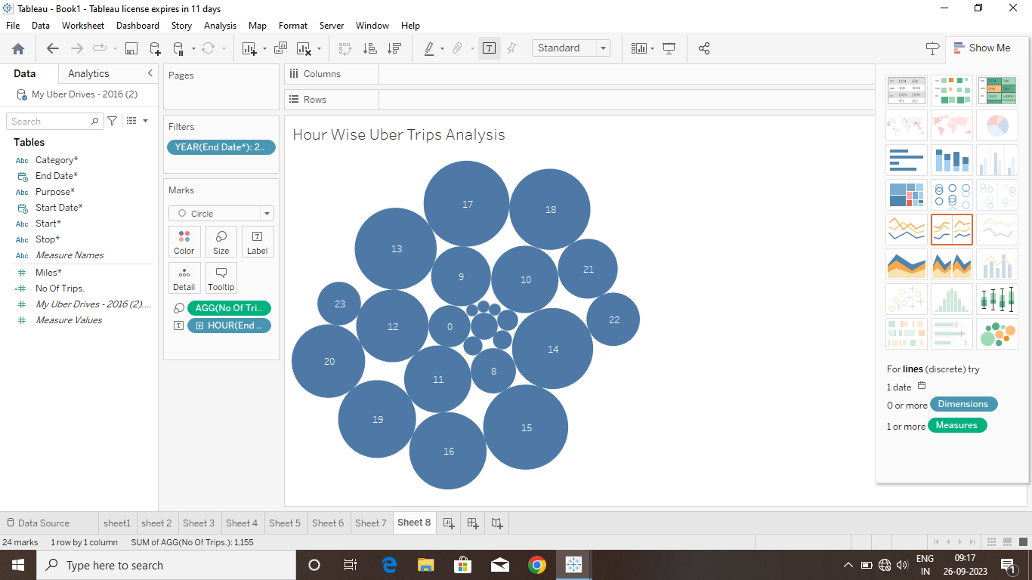

MILESTONE 5 :DASHBORD

A dashboard is a graphical user interface (GUI) that displays information and data in an

organized, easy-to-read format. Dashboards are often used to provide real-time monitoring and analysis of data, and are typically designed for a specific purpose or use case. Dashboards can be used in a variety of settings, such as business, finance, manufacturing, healthcare, and many other industries. They can be used to track key performance indicators (KPIs), monitor performance metrics, and display data in the form of charts, graphs, and tables

ACTIVITY :1 -RESPONSIVE AND DESIGN OF DASHBOARD

The responsiveness and design of a dashboard for Data-Driven insights on YouTube channels Analysis is crucial to ensure that the information is easily understandable and actionable. Key considerations for designing a responsive and effective dashboard include user-centered design, clear and concise information, interactivity, data-driven approach, accessibility, customization, and security. The goal is to create a dashboard that is user-friendly, interactive, and data-driven, providing actionable insights.

ACTIVITY 1: DASHBOARD 1

https://public.tableau.com/app/profile/s.vennila.s.vennila/viz/Book1_16959764468370/Story1?publish=yes#WelcomeQuestionnaire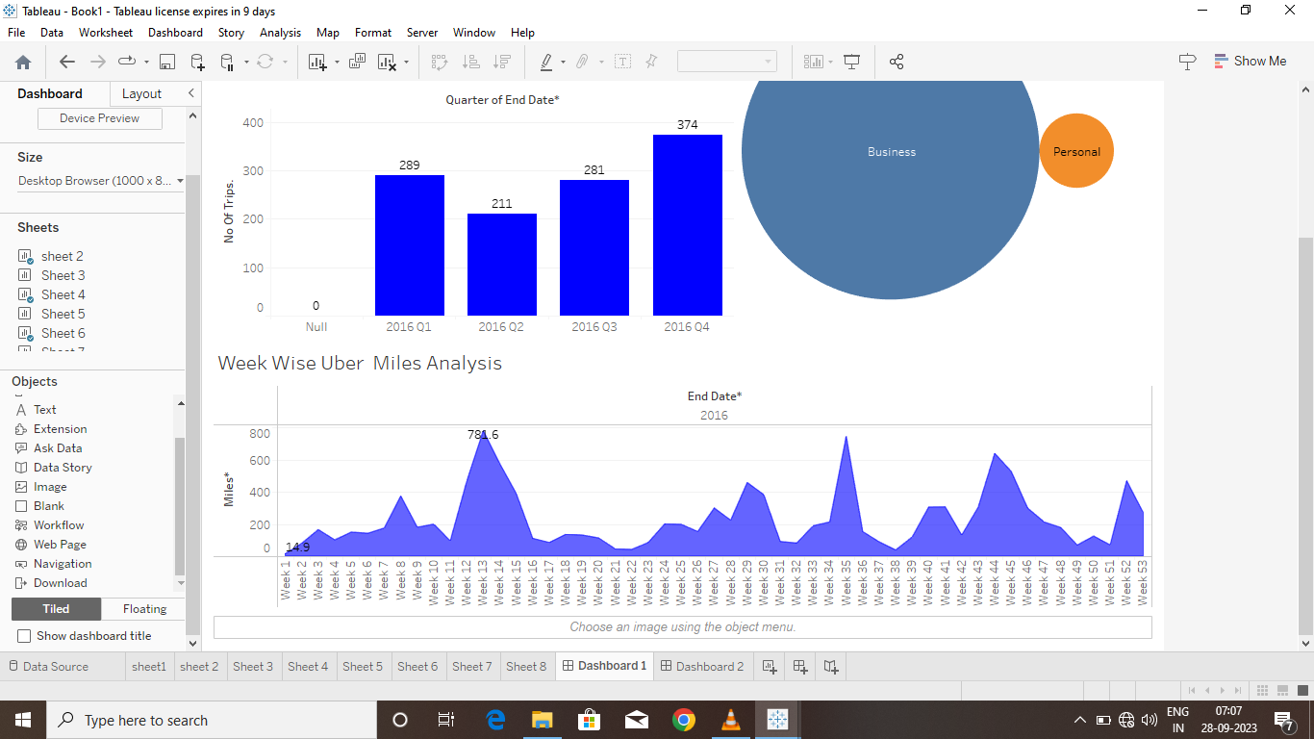

ACTIVITY 1.2 :DASHBOARD 2

https://public.tableau.com/app/profile/s.vennila.s.vennila/viz/Book1_16959764468370/Story1?publish=yes#WelcomeQuestionnaire

MILESTONE 6:STORY

A data story is a way of presenting data and analysis in a narrative format, with the goal of making the information more engaging and easier to understand. A data story typically includes a clear introduction that sets the stage and explains the context for the data, a body that presents the data and analysis in a logical and systematic way, and a conclusion that summarizes the key findings and highlights their implications. Data stories can be told using a variety of mediums, such as reports, presentations, interactive visualizations, and videos.

ACTVITY 1:NO OF SCENES OF STORY

The number of scenes in a storyboard for Data-Driven insights on YouTube channels Analysis will depend on the complexity of the analysis and the specific insights that are trying to be conveyed. A storyboard is a visual representation of the data analysis process and it breaks down the analysis into a series of steps or scenes

ACTIVITY 1:STORY

<https://public.tableau.com/app/profile/s.vennila.s.vennila/viz/Book1_16959764468370/Story1?publish=yes#WelcomeQuestionnaire>

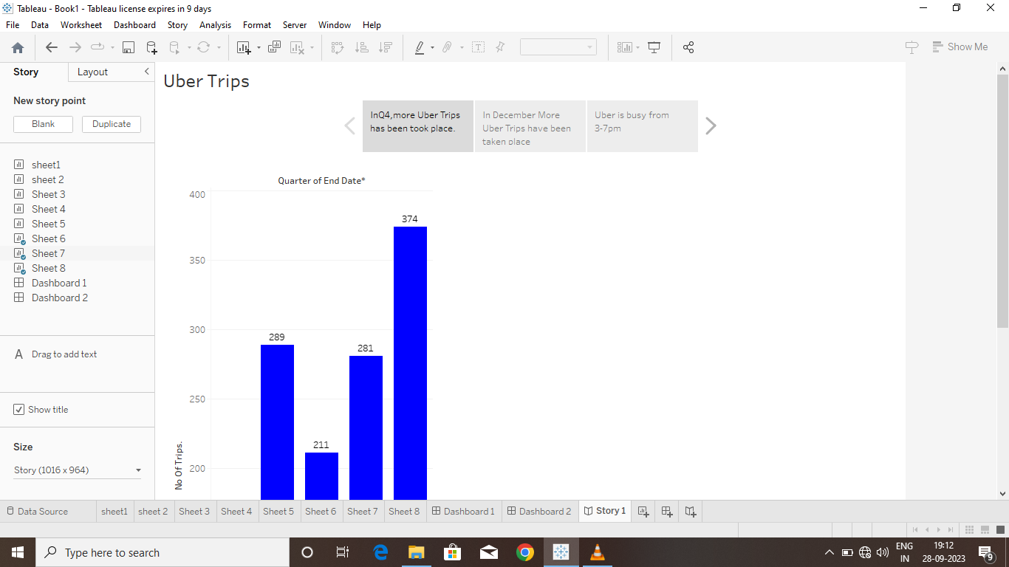

MILESTONE 1:PUBLISHING

DASHBOARD 1,2:

<https://public.tableau.com/app/profile/s.vennila.s.vennila/viz/Book1_16959764468370/Story1?publish=yes#WelcomeQuestionnaire>

STORY :1

https://public.tableau.com/app/profile/s.vennila.s.vennila/viz/Book1_16959764468370/Story1?publish=yes#WelcomeQuestionnaire